Autumn 2 Overview
Reception
We will be learning the following this half term
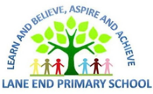  Maths  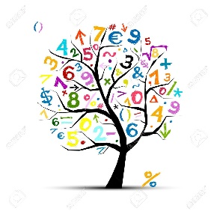 | Throughout this half term the main areas we will be covering are:  - Representing numbers 1-5  - Comparing numbers 1-5  - Composition of numbers 1-5  - Shapes – circles, triangles, squares and rectangles  - Positional language
Literacy  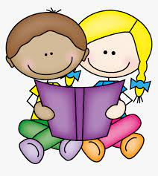 | Reading – we will be continuing to follow the Little Wandle Letters and sounds programme in phonics. We will be learning about digraphs- 2 letters that make 1 sound. We will be reading words containing these digraphs. We will look at the following texts as our key texts – The Billy Goats Gruff, Little Robin Red Vest and Father Christmas needs a wee. We will also learn the nativity story.  Writing – we will be continuing to focus on holding the pencil with a tripod grip to write our first name independently. We will also be thinking about writing labels for our pictures, listening for the sounds we can hear. We will be practising writing letters with the correct formation for the sounds we have learnt.
Understanding the World  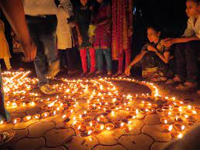 | This half term we will be thinking about celebrations and the different festivities that are celebrated at this time of year. We will be working on the following skills:  - Understanding and talking about how people celebrate different festivals  - How to keep ourselves safe on Bonfire night  - Learn the story of Diwali and the Story of the Nativity  We will also be learning about important figures in our community and how they have changed since the past. This will include doctors, nurses, dentists and firefighters. We will develop the skill of talking about similarities and differences between the past and present
Personal, Social and Emotional development  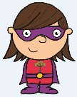 | We will be introducing our super learning power hero Collaborative Cara. We will be learning the skill of working with other children peacefully, collaborating on tasks.  We will take part in class circles discussing our emotions.
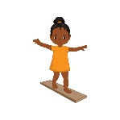  Physical development | Continuing to focus on our pencil grip and holding the pencil effectively. To continue to develop writing taught letters with the correct formation  To develop our gross motor skills working on moving with confidence and safely.
Communication and language  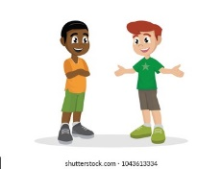 | This half term we will be developing the following skills:  To join in with repeated refrains in a story, engaging in daily story time  To continue with our active listening and skilful speaking – thinking about listening carefully to adults and children and thinking of an idea to talk about  To use key vocabulary that children have been introduced to within their provision  To understand how to start to retell a story
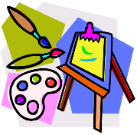  Expressive arts and design | We will be learning a range of songs for our school production that we will perform for an audience  We will begin to develop ideas for deconstructed role play  We will talk about our creations in review time  We will use a range of materials to construct with to make items linked to celebrations  We will represent our ideas to make a Christmas card

This half term is a busy one, full of glitter and joy! We have a few dates for your diary:

21st November 9am – phonics workshop. Come to the hall after drop off, have a cuppa and learn about our phonics scheme, “ Little Wandle,” how we teach your child to read and write in Reception and crucially, how you can support us with that at home.

12^{th/} 13th December – EYFS Nativity performance – further details will follow in a letter regarding times and tickets.

Remember – stay and read every Thursday morning 8:45- 9:15am. Come along and choose a bedtime story to share.

We have had a few parents ask about PE. We will start our PE sessions in January. There will be further details to follow in a separate letter.

As always, if you have any questions, please don’t hesitate to speak to a member of the Reception team.

