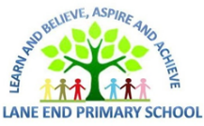
Spring 1 curriculum overview
Reception
We will be learning the following this half term
Maths  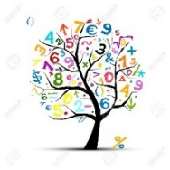 | Throughout this half term the main areas we will be covering are:  - Exploring composition of numbers – looking at how numbers are made up. We will be exploring numbers inside numbers as this is the first part of addition and subtraction.  - We will also be looking at numbers 6,7 and 8. We will be thinking about what this looks like ( on a dice for example) counting out amounts and thinking about how we can represent these numbers ( 5 and 3 more, 5 and 2 more) for example.
Literacy  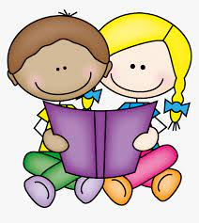 | We will be continuing our work on the little wandle progression of sounds.  - Children will be reading and writing words using digraphs. These are two letters that make one sound. We will look at digraphs that are in the middle of words such as “ai” “oa” and “oo”. .  - Our key texts this half term are, “One Snowy night ” by Nick Butterworth, Jack Frost and The Great Race. Children will be developing their writing skills based on these texts.
Understanding the World  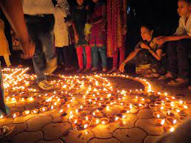 | This half term we will be using our theme of “Winter” to think about the changes of the season. We will be exploring freezing and melting and also what we notice when we explore the natural world around us.  We will be learning about the celebration of Chinese Lunar New Year, thinking about how people celebrate.
Personal, Social and Emotional development | Our PSED development this half term focusses on developing independence  - Children will be introduced to Reflective Ralph and will be keenly thinking about persevering in the face of a challenge.  - The feelings that we will be exploring in our class circles will focus on the feelings that we have when something goes wrong and how we can overcome this.
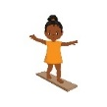  Physical development | This half term we start our work in formal PE lessons in the hall. These lessons take place on a Thursday. We are particularly focussing on  - Travelling safely on my hands and feet around a space  - Developing balance and large scale movements.
Communication and language  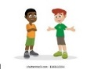 | This half term we will be developing the following skills:  - Retell of the story, once they have developed a familiarity with the text. We will use Pie Corbett’s talk 4 writing to retell the story of Percy the Park Keeper, then change it to our own story.
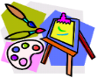  Expressive arts and design | This half term we will be thinking about  - We will explore painting techniques linked with tone – we will think about tones of white and blue linked to winter and how to create these, and embed this fully with tones linked with Valentines Day.

How can I support my child at home?

- Please, please, please read with your child AT LEAST 3 times in the week. Children will read one to one with an adult, at least once a week. Repeated practice at home supports their confidence as readers.

- Find opportunities for your child to write for a purpose at home. Can they write a shopping list? Can they write the inside of a birthday card? Can they make a message to a loved one that could be posted?

- This half term we will be thinking about Winter. Why not go on a Winter walk and discuss what your child can see? We will be thinking about frost, ice, snowflakes, melting, freezing and changes. Can you use them words while you are out and about?

- Visit your local library. There is no better feeling that snuggling down with a book – as well as sharing the bedtime story from school.

- Remember – oral health is so important. Is your child due a dental check up? Do you need support and advice on getting a dentist? Speak to a member of the Reception team for information about services near us.

