Summer 2 Overview
Reception
We will be learning the following this half term
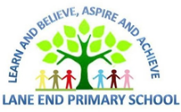  Maths   | Throughout this half term the main areas we will be covering are:  - Sharing and grouping  - Odd and even numbers  - Consolidating our key skills in number – such as subitising, composition  - Spatial reasoning
Literacy   | In our phonics this half term there is a focus on reading and writing longer words. These words are called cvcc and ccvc words. These are words such as bend and snap ( c stands for consonant and v vowel) . We will then apply this new skill into reading longer compound words such as handstand, toothbrush and starfish.
Understanding the World  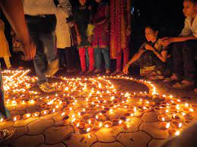 | We are developing our knowledge of the world and places that are different to where we live. We are so lucky to have children whose families come from all over the world, so we will be using our map skills to think about places we can call home all over the world! We will then learn about holidays we can go on around the world. We will be thinking about the signs of Summer and how this is different to the different seasons of the year.  We will also be taking a special trip to Lotherton Hall to look at animals from all around the world.
Personal, Social and Emotional development | This half term we will be thinking about developing the focus we spend on activities, both chosen and given by an adult, in preparation for moving into year 1. We will be taking part in class circles and reflecting on our school year.
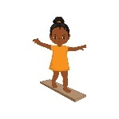  Physical development | This half term in PE we will be honing our skills ready for sports day! Following sports day, our PE sessions will focus on ball skills and games, getting ready for year 1.
  Communication and language | This half term we will be developing the following skills:  - Learning and using vocabulary linked to our theme  - Talking about sports day in detail and reflecting on our year  - Listening to and following chunked instructions of several steps
  Expressive arts and design | This half term we will be thinking about linking our arts and design skills to our themes. We will be working on  - . Drawing with increasing detail  - Thinking about the progress we have made with our self portraits

How can I support my child at home?

- Read your child’s take home book with them at least 3x a week. Remember, this is your child’s show off book so they should be really confident with the sounds that they are blending in their book.

- Ask questions about your child’s bedtime story. Stop at regular pages and ask what, where, who, when, how and why questions allowing them to think about what has been read to them. Using the pictures is a good tool too. You might ask, “What do you see/ notice?” on a page to get them really looking at the pictures.

- On hot, sunny days, talk about how we need to keep ourselves ‘sun safe’. Think about the need for sun cream, staying in the shade, drinking lots of water and the clothes that keep us safe in the sun.

- Practice writing for ‘purpose’ in different ways. If you are going shopping, can your child write a shopping list? If you have birthdays coming up, can your child write the card? If they are singing a song, can they write the words? Allow them to say each word slowly, listen for the sounds they can hear and write them. This is fine while children are still learning to write. If your child does any writing at home, don’t forget to take a picture and add it to Tapestry so that we can celebrate it!

As always, if you have any questions or queries, please don’t hesitate to speak to a member of the reception team.

