Lane End Year 6 Spring 2 Parent newsletter
REMINDERS:
PE: Children are to come to school dressed and ready in a WARM PE kit please on MONDAYS when they will be working on their speed, agility and accuracy in netball.
Spellings: These are given out on a Monday and are to be practised throughout the week for a test every Friday – with a few unseen but similar words thrown in for good measure!
Reading: Children will continue to bring home levelled (‘show-off’) books and we would love for them to read at least 5 times a week for a minimum of 10 at a time (7 times a week would be epic! ) and to bring them back to school each day. Feel free to ask your child about the content of these books which they should be able to read fluently and with expression. (They have other, higher-levelled books in their trays at school but we also encourage the children to bring these home too if they so wish; the more books and practice, the merrier). We check reading record books every Monday – and there may be some class rewards up for grabs! Please help by signing your child’s yellow reading record book if you have heard them read.
DATES FOR YOUR DIARY
Open Afternoon: WEDNESDAY 28TH FEBRUARY 2024 – please come and see what we do!
World Book Day: THURSDAY 7TH MARCH 2024 – children are very much invited to come into school dressed as a book or film character; there may even be prizes on offer..
Parent/Carer consultations: WEDNESDAY 27TH MARCH 2024 (appointment availability will be made accessible nearer the time).
Lane End Art Exhibition: WEDNESDAY 27 TH MARCH 2024 (same as the above) - come see the artists of the future.
Half term: SATURDAY 29TH MARCH TO SUNDAY 14TH APRIL 2024 (starting back on MONDAY 15TH APRIL 2024)
The Big Question (geography focus): Why do changes happen?
Geography:  Our topic this half term will centre around ‘Our Changing World’ where we will consider the ways in which the world around us is changing, from coastal erosion and weathering to political changes and urban regeneration. We will discuss how the physical geography of the UK has changed over thousands of years and will consider the impact of natural disasters - both the negative impact but also how people cope and learn from such potential catastrophes.  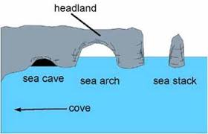 | Science:  This half term, we are looking at Evolution and Inheritance. We will learn about eminent scientists in this field such as Mary Anning and her pioneering work in palaeontology, and Charles Darwin and his theories on the Origin of Species; we will consider how and which characteristics can be inherited or may vary; we will consider how different animals are adapted to their differing habitats; and we will sort animals using cladograms!  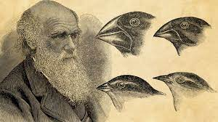 | English:  Writing  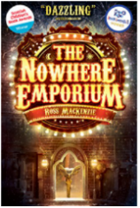  This half term, we will be concentrating our efforts on pulling our numerous punctuation, vocabulary and compositional skills together to work on a timeslip narrative based on ‘The Nowhere Emporium’ where our main character switches time dimension…  Reading  In reading, we will continue to work hard at improving our overall fluency in terms of speed and accuracy, as well as sharpening our reading comprehension skills by deciphering and answering questions related to inference and deduction, language and authorial technique through our study of information texts, biographical writing and (mild) horror!  Please help us help your children to improve their comprehension, ability to read expressively and with accuracy and speed by hearing them read as often as possible. Encouraging them to get lost in a book will really serve them well for the future and will help improve in many areas – spelling, vocabulary, imagination, plotlines, character development, grammar…   | SPaG (Spelling, Punctuation and Grammar)  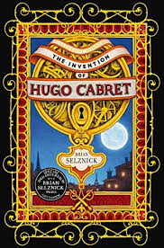  We will continue on our path towards becoming proficient spellers by looking at rules and patterns such as -ture/cher,  -fer, -ous/us as well as ensuring we are familiar with the Year 5/6 word list, spelling such delights as privilege, foreign, mischievous and immediately. In SPaG, we will be whistling through all manner of concepts such as word classes, tenses, in/direct speech and the active and passive.
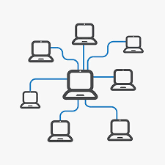  Computing:  This half term and next, the children will be doing work based on computer networks as well as, as always, being reminded how to stay safe online and how to report anything that worries them.    Spanish:  We will be learning about how to talk about food!    PSHE:  This half term’s topic is Rights and Respect and we will be discussing what we should expect in terms of behaviour from others and what is not acceptable.  R.E.    The children will be discussing matters concerning what makes Easter important for Christians. |  |  | Maths:  In maths, we will be continuing to hone our arithmetic skills and overall maths fluency; we will also be tackling areas such as multiplying fractions, ratio and proportion, and percentages and learning to calculate the area, perimeter and volume of differing shapes.  

