Lane End Year 6 Autumn 1 Parent newsletter
REMINDERS:
PE: Children are to come to school dressed and ready in a WARM PE kit and trainers please on MONDAYS when they will be working on their athletic prowess.
Spellings: Out on a Monday and to be practised throughout the week at home for a test every Friday – with a few unseen but similar words thrown in for good measure. (Spellings will only start in week 3 of this half term).
Reading: Children will be bringing home levelled, ‘show off’ books and, in Year 6, there is an expectation that the children read at home for a minimum of 10 mins each day, at least 5 times a week (7 times a week/for longer would be epic!). We ask that they bring them back to school each day. We will be checking reading record books every Monday – and there may be some class rewards up for grabs! Please help by signing your child’s yellow reading record book if you have heard them read.
DATES FOR YOUR DIARY
Start of the Year meeting: 3.30pm, Tuesday 19th September 2023 (20 mins) – to let you know key info, how your children are getting on etc
Parent/carer consultation evening: Wednesday 25th October 2023 (online booking form available nearer to the time)
Lane End Carnival: afternoon of Thursday 26th October 2023 (more details to come!)
Half term: Saturday 28th October – Sunday 5th November 2023 (back to school on Monday 6th November 2023)
High school choices deadline: Tuesday 31st October 2023 (during the October half term) – FIVE high school choices to be made – WE CANNOT STRESS THIS ENOUGH!
The Big Question (history focus): Did the punishment always fit the crime?

History:  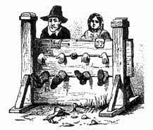  In history, we will be studying…crime and punishment in Britain through the ages! As well as considering attitudes to crime and criminals and the ethics of differing punishments, the children will be deepening their historical awareness and understanding of how our past is constructed through differing accounts. |  |  | Science:  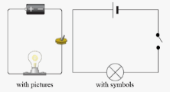  We will be building on our knowledge of electrical circuits, investigating the impact of increasing or decreasing the number of components such as buzzers, bulbs and cells, and learning how to record that information by drawing circuit diagrams. We may even put together a burglar sensor in a bid to fight crime! | English:  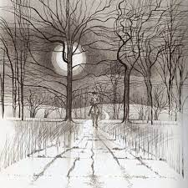  This half term, we will be writing a short, scary story with a twist, expressing the thoughts of a highwayman or those connected to him, and constructing newspaper reports based on well-known fairy tales.  In reading, we will begin our journey towards mastering all manner of reading skills through our reading of cautionary tales, mysterious destinations and tales of survival.  We have some avid readers in Year 6 so please help us help your child improve their depth of understanding and fluency by hearing them read and encouraging them to get lost in a book for a minimum of 10 mins every night! Every time they are heard aloud, they will need an adult’s signature – and signatures make prizes…!   | SPaG:  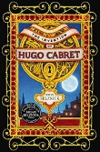  We will be kicking off our attempt to nail spelling, punctuation and grammar this half term by looking at all manner of tools such as sentence types, main and subordinate clauses, relative pronouns through our study of the book, ‘The Invention of Hugo Cabret’. Spellings will focus upon commonly-used words, prefixes, homophones and the suffixes -tion, and -ssion.
Art:  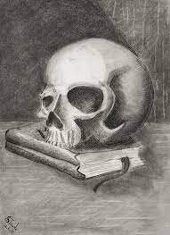  We will be focussing our attention on drawing, mastering techniques such as the use of lines to represent movement, capturing light and reflection and composition. |  | Computing:  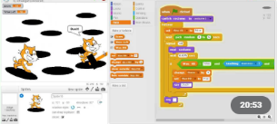  We will be looking at programming, how video games are designed and they will be creating their own simple game using computer software to include elements such as characters and objects to collect and avoid. |  |  | Maths:  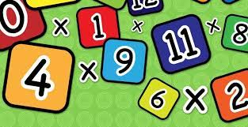  We will hit the ground running by reminding ourselves of place value and key calculation methods for the differing operations as well as building our confidence with regards to tackling problems and explaining our reasoning. We will also be working on our quick recall of times tables facts and looking to improve our bank of skills in terms of arithmetic problems.
Music:    We will be honing our singing skills, performing parts from memory. | MFL:  Our Spanish for this half term will focus on greetings, classroom instructions and days of the week and the months.  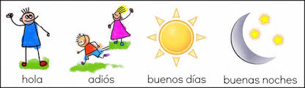 |  |  |  | DT:  We will be preparing – and savouring of course – food from a nation different to our own.  

