Lane End Year 6 Autumn 2 Parent newsletter
REMINDERS:
PE: Children are to come to school dressed and ready in a WARM PE kit please on MONDAYS when they will be working on their agility, strategy and accuracy in rugby.
Spellings: These are given out on a Monday and are to be practised throughout the week for a test every Friday – with a few unseen but similar words thrown in for good measure! (No spellings during any assessment week, however).
Reading: Children will be bringing home levelled, ‘show off’ books and, in Year 6, there is an expectation that the children read at home for a minimum of 10 mins each day, at least 5 times a week (7 times a week/for longer would be epic!). We ask that they bring them back to school each day. We will be checking reading record books every Monday – and there may be some class rewards up for grabs! Please help by signing your child’s yellow reading record book if you have heard them read.
DATES FOR YOUR DIARY
Christmas holidays: FRIDAY 22ND DECEMBER 2023 TO MONDAY 7TH JANUARY 2024 (starting back on TUESDAY 8TH JANUARY)
The Big Question (history focus): Did the punishment always fit the crime?
History:  Our Crime and Punishment in Britain Through the Ages topic continues, moving on to attitudes in Tudor times, Victorian Britain and the Modern Day. We will also home in on particular character of legend - the infamous highwayman, Dick Turpin, looking at both primary and secondary sources and interpretations through art and literature to consider whether he was a hero or a villain…  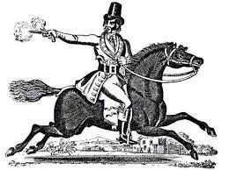 | Science:  Our topic this half term is Light. We will be looking at how light travels, how shadows are formed, carrying out investigations re how distance from a light source affects the size and clarity of a shadow, and how the human eye helps us to see things.  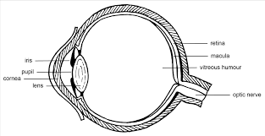 | English:  Writing  This half term, we will be writing setting descriptions for abandoned theatres, schools and houses, and character descriptions for creatures hiding in the shadows, as well as creating ‘WANTED’ posters for metal menaces based around ‘The Iron Man’.  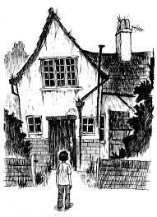  Reading  We will continue to hone our inference and deduction skills, our ability to mould the answer to the question being asked and to read critically at speed through our study of stories by the likes of Chris Van Allsburg’s ‘The Garden of Abdul Gasazi’ – SO good!) and the poetry of the WW1 poet, Wilfred Owen, in recognition of Remembrance Day.  Please help us help your children to improve their comprehension, ability to read expressively and with accuracy and speed by hearing them read as often as possible. Encouraging them to get lost in a book will really serve them well for the future…   | SPaG  (Spelling, Punctuation and Grammar)  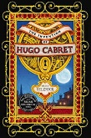  We will be continuing to build a bank of spelling rules and patterns, looking at -sion and -cian words, the -tious/-cious/-xious endings, ‘i before e except after c’ words…We will also be covering all manner of SPaG concepts such as fronted adverbials, modal verbs and prepositions.
Computing:  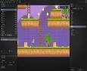  This half term, the children will be learning programming…and how to make a video game!  Spanish:    Our learning this half term will be number-based – we will be practising how to say dates and ages.  PSHE:    This half term’s topic is Valuing Differences where we will be thinking about the things that make us the same as, and different from, others in our lives and our community.  R.E.  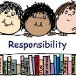  The children will be considering the question, How does growing up bring responsibilities and commitments? |  |  | Maths:  We will be working on a whole lots fractions – adding them, subtracting them, multiplying them, dividing them…with a few tricks thrown in along the way! We will also look at converting units, and building on the quick recall of multiplication and division facts in order to keep our skills razor-sharp.  

