

School Travel Plan

June 2015



In partnership with

Document Control Sheet
Project Title Lane End Primary School Report Title Travel Plan
Revision V0.12

Issue | Status | Author | Date | Check | Date | Authorised | Date
V0.1 | Draft | L. Low | 17/09/12
V0.10 | Draft | B Hardy | 24/06/13
V0.11 | Draft | B Hardy | 19/08/13 | B Hardy | 19/08/13
V0.12 | Draft | B Hardy | 21/08/13 | B Hardy | 21/08/13
VO.13 | Draft | A.Britton | 09/06/15

Organisation | Contact | Copies
Leeds City Council | Client Team | 1
Leeds City Council | Sue Walker | 1

Contents
Document Control Sheet i
Contents ii
- Executive Summary 1
- Introduction 3
- Focus & Benefits 6
- Introduction to Lane End 8
- Travel Behaviour – Local Schools 17
- Objectives 19
- Travel Plan Targets 21
- Travel Plan Measures 23
- Travel Plan Management 26
- Marketing & Promotion 27
- Monitoring & Review 28
- Action Plan 30

Figures

Figure 4-1 – Lane End Primary School Location 8
Figure 4-2 – Primary Schools within the Local Area 9
Figure 4-3 – Local Highway Network 11
Figure 4-4 - Local Bus Network Stops 12
Figure 4-5 – Local Cycle Network 14
Figure 4-6 – Local Rail Network 15

Tables

Table 4-1 – Primary Schools within Local Area 9
Table 4-2 – Anticipated School Pupil Numbers 10
Table 4-3 – Local Bus Services 12
Table 4-4 – Lane End Primary School Summary 16
Table 5-1 – 2011/2012 Travel Mode Survey Results 17
Table 5-2 – Average Staff Travel Mode Survey Results 18
Table 7-1 – Pupil Mode Split Targets 21
Table 7-2 – Staff Mode Split Targets 22
Table 11-1 School Travel Plan - Monitoring Plan 28

Appendices

Appendix A - Action Plan 31
Appendix B - Commitment Charter 35
Appendix C - Proposed Highway Improvements 36
Appendix D - Proposed Site Layout 37
Appendix E - Commitment to STARS…….. ……………………………………………...36

Executive Summary

Background
This Travel Plan document forms part of the planning application for a proposed development of a new Primary School on the former site of South Leeds Sports Centre, located on Beeston Road, Leeds. It is proposed that the existing sports facility will be demolished to make way for a new Primary School, which would have a capacity for 420 pupils as well as a 26 place nursery. At this stage it is anticipated that that the proposed number of staff at the school would be around 50, including support staff.

Aims & Targets
The School Travel Plan is designed to mitigate against the impact of pupil and staff travel, and reduce the traffic impact on the surrounding area. This Travel Plan focuses on pupil travel behaviour and aims to encourage and consolidate active travel choices amongst pupils and also aims to benefit staff, visitors, parents and guardians.

This Travel Plan will cover the school development period from 2014 up to 2020 when the school has reached full 2FE capacity. This will ensure that the school develops within a sustainable travel framework, minimising the impact of the people travelling to the site from the surrounding area. The following Travel Plan aims will be adopted for the proposed Lane End Primary School.

    - To promote and facilitate walking and cycling journeys to school by pupils, staff and visitors;

    - To encourage travel by bus (sustainable travel);

    - To encourage low levels of single occupancy car use to the site;

    - To promote the use of car sharing amongst staff that travel to the site;

    - To raise awareness and develop a mechanism to deliver the Travel Plan amongst pupils, parents and staff;

    - To educate and raise awareness of the environmental and health benefits of choosing sustainable travel modes; and

    - Create a safe environment and provide the skills to tackle perceptions of safety for both parents and pupils.

In order to achieve these aims, the Travel Plan has targeted objectives which are outlined in detail in Section 6.2.2. It will be important for the Travel Plan to promote sustainable travel choices and discourage single occupancy car use. The Travel Plan targets will be based upon an initial travel survey undertaken when the Lane End Primary School site becomes operational, and will be set for the period up to

2020. It will also be important for the Travel Plan to have a positive impact on staff travel to and from the school. As such, it will be necessary to undertake regular travel surveys covering staff, inline with the annual pupil surveys, as this will demonstrate the change in travel mode over the travel planning period. Staff travel targets will also be set for the period up to 2020.

Travel Plan Measures & Management
This document outlines a range of sustainable transport solutions that can help achieve the aims stated above, and the objectives stated in Section 6.2.2. Primarily these interventions or solutions include supporting more sustainable travel choices, encouraging walking and cycling, as well as marketing and promotion.

To manage the travel planning process, the school has individuals in place designated as leads on various initiatives (see the Action Plan in Appendix A). The School Travel Plan Coordinator is Luke Tabiner.

The school has signed a commitment charter (see Appendix B) outlining our commitment to managing the Travel Plan, implementing the measures described within this document and monitoring travel for the duration of the Travel Plan period.

Introduction

Background
Lane End Primary School will be a large primary school with an anticipated 420 pupils on roll between the ages of four and eleven as well as 26 nursery places.

As part of the school’s development, this Travel Plan is a condition of the planning permission and will align with Leeds City Council’s commitment to reduce car travel, increase physical activity and improve child safety. This Travel Plan was originally produced by Mouchel in partnership with Leeds City Council to cover the period from 2014 up until the school is at full capacity in 2020.

It should be noted that in the official school opening year of 2014, the Lane End site was not used, and the Lane End reception pupil intake were accommodated in temporary classrooms at Cockburn High School. In the 2015 academic year, these pupils will then transfer over to the Lane End Primary School site, together with the new reception intake. As such, 2015 will be the first year when pupils occupy the Lane End Primary School site.

A Travel Plan Statement together with an updated Cockburn High School Travel Plan takes account of the sustainable travel needs and targets for the 2014 academic year. This Lane End Primary School Travel Plan will therefore only take effect from the occupation of the Lane End Primary School site, in 2015. During the 2014 academic year, at the time of the temporary usage of the Cockburn High School site, measures will be put in place in preparation for the 2015 opening of the Lane End site.

National Travel Plan Policy & Guidance
    - Department for Transport (DfT)
The Government target is that all schools should have had active School Travel Plans by 2010 to help improve safety, promote healthy lifestyles and increase environmental awareness.

The 1998 Government White Paper ‘A New Deal for Transport: Better for Everyone’ marked the start of a new era in transport policy. This document identified school Travel Plans as one way of delivering an integrated transport policy aimed at reducing congestion and pollution. At this time the national percentage share of children travelling to school by car had risen from 16% in the mid eighties to 28% in 1998 and was recorded as 30% in 2003. More recently the Government White Paper: “The Future of Transport: A Network for 2030”, published in July 2004, continues to view the production and implementation of school Travel Plans as a fundamental part of delivering the national transport agenda, including through specifically focussed strategies such as Accessibility Planning and the National Road Safety Strategy ‘Tomorrows Roads – Safer for Everyone’ which introduced casualty reduction targets for 2010.

The Government published the White Paper ‘Creating Growth, Cutting Carbon: Making Sustainable Transport Happen’ in January 2011. The document emphasises that there is significant potential for journeys under five miles to be taken by more sustainable modes of travel. Specifically it looks at the need to make undertaking these journeys by walking, cycling and public transport more attractive and viable by providing a framework that will enable a mode shift to sustainable modes for shorter journeys.

    - Education & Inspections Act (2006)
Chapter 40, Part 6 (section 76) relates to LEAs in England: ‘duty to promote sustainable modes of transport.’ This document includes duties which a local education authority in England must abide, this includes:

      - Prepare for each academic year a document containing their strategy to promote the use of sustainable modes of travel to meet the school travel needs of their area (“a sustainable modes of travel strategy”);

      - Publish the strategy in such manner and by such time as may be prescribed;

      - Promote the use of sustainable modes of travel to meet the school travel needs of their area.

    - National Institute for Health Care and Excellence (NICE)
Public Health Guidance 41 (PH41) relates to walking and cycling: local measures to promote walking and cycling as forms of travel and recreation. The guidance aims to set out how people can be encouraged to increase the amount they walk or cycle for travel or recreational purpose. Recommendation 8 of this guidance relates to schools and the actions of which include:

      - Foster a culture that supports physically active travel for journeys to school (staff, parents and students).

      - Develop and implement school Travel Plans that encourage children to walk or cycle all or part of the way to school.

      - Map safe routes to school and to local play and leisure facilities.

      - Introduce regular ‘walking buses’ and other activities which encourage walking and cycling to school.

      - Set performance targets for school Travel Plans.

      - Ensure all children can take part in ‘Bikability training’.

      - Schools should develop parents’ and carers’ awareness of the wider benefits of walking and cycling.

      - Head teachers should identify a walking or cycling champion with sufficient senior support to coordinate activities.

    - Travel Plan Policy & Planning Permission
Travel Plans are now an integral part of most Planning Applications. In the case of Lane End Primary School, developing a Travel Plan will help the school mitigate the travel impact of the new school and ensure that the school can continue to grow and expand sustainably. This philosophy has been discussed with Leeds City Council together with the Sustainable Education Travel Plan Coordinator.

2.3 Local Travel Plan Policy & Guidance
Leeds City Council is committed to helping all schools across the county to implement, monitor and review their STP as part of LCC’s Sustainable School Travel Strategy. LCC provides schools with support and guidance on producing, reviewing and managing School Travel Plans through their School Travel Advisors.

Focus & Benefits

Travel Plan Audience
This Travel Plan focuses on pupil travel behaviour with aims to encourage more active travel choices; however, this Travel Plan also aims to benefit staff and visitors as well as parents and guardians.

Travel Plan Benefits
Travel Plans have a range of benefits to a number of users; some of these are identified below:

    - Benefits to the School
      - Reduce traffic in and around the school vicinity;
      - Improve safety and reduce pollution;
      - Improve relationships with the local community;
      - Demonstrate a school's commitment to addressing environmental issues;
      - Attract pupils – better ethos, safer and more convenient journeys;
      - Provide a framework for curriculum links (aspects of PSHE/Geography or Citizenship);
      - Help with Ofsted inspections; and
      - Feed into the Every Child Matters agenda.

    - Benefits to pupils
      - Improve road safety skills;
      - Improve fitness levels through increased levels of walking or cycling;
      - Increase travel awareness;
      - Arrive at school alert and ready to learn; and
      - Time to talk to friends and parents on the walk to school.

    - Benefits to parents
      - Improve journey quality;
      - Increase community awareness by working together;
      - Strengthen home-school links;
      - Reduce driving stress.

    - Benefits to the Local Community
      - Improved air quality;
      - Reduced traffic levels;
      - Reduced parking issues for local residents; and

      - Improved pedestrian and cyclists facilities.

    - Benefits to the Environment
A successful Travel Plan will lead to a change in modal shift and a reduction in the use of the car. Road transport makes up just over 90% of all domestic transport emissions, with car travel accounting for over half (58%). As is the case with greenhouse gas emissions, emissions from road transport accounts for the majority of local air quality pollution.1

Helping reduce reliance on the car may lead to improvements in local air quality and help address the impacts of climate change.

1 Transport Energy and Environment Statistics, 2011 (DfT)

Introduction to Lane End

Background
It is proposed to develop a new Primary School with a maximum capacity of 420 pupils and a 26 place nursery. The existing sports facility will be demolished and a new two storey school built. As the anticipated staff level is expected to be in the region of 50, it is proposed to create a new car park on the site of the school with 38 allocated spaces, which includes provision for disabled and visitors. Figure 4-1 below illustrates the wider context of Lane End Primary School.

Figure 4-1 – Lane End Primary School Location
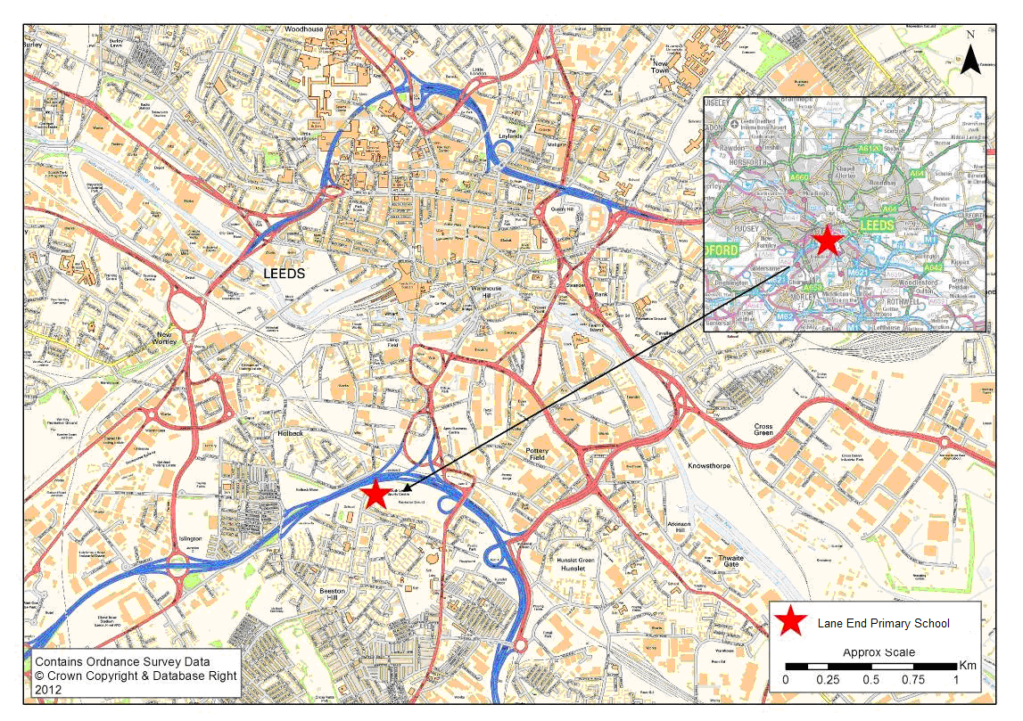

    - School Location & Catchment Area
The proposed school is situated in close proximity to a number of other primary schools. Table 4-1 outlines the schools, including church schools, within close proximity to the Lane End Primary School site. Figure 4-2 provides a plan which illustrates these neighbouring schools in relation to the Lane End Primary School site.

Table 4-1 – Primary Schools within Local Area

Distance from Lane End (As the Crow Flies) | Schools
0.5 Mile Radius | Beeston Hill St. Luke’s, Greenmount, Hunslet Moor, New Bewerley, St Francis of Assisi
0.75 Mile Radius | Cross Flatts, Ingram Road
1 Mile Radius | Beeston St Anthony’s, Hunslet St Joseph’s, Hunslet St Mary’s C of E

Figure 4-2 – Primary Schools within the Local Area
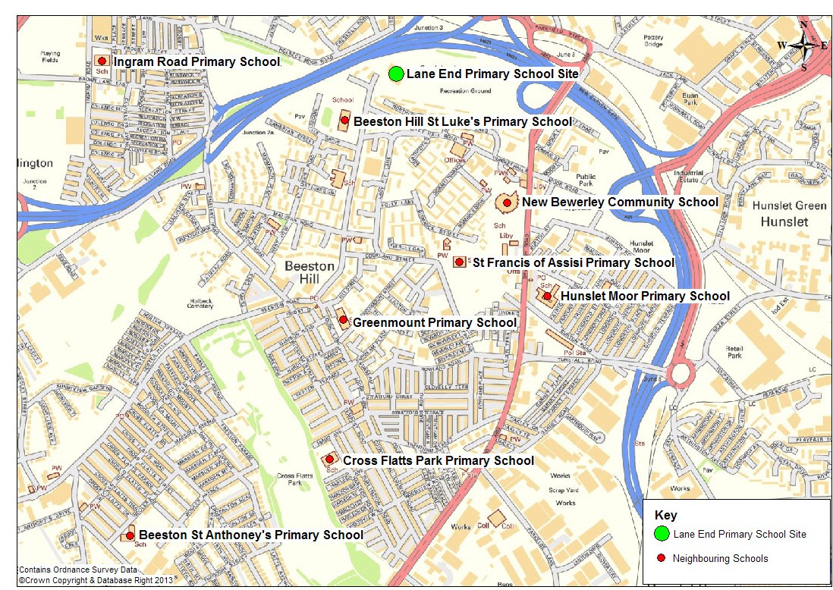

    - Proposed School Size
The school will gradually fill to its capacity of 420 pupils plus 26 nursery places by 2020 over seven years. As discussed in Section 2.1, the first pupil intake would not be on the Lane End site, but accommodated temporarily for one year at Cockburn High School. In the 2015 academic year, these pupils will then relocate to Lane End Primary School together with the new reception intake. As such, the 1st September 2015 would be the first year when pupils are on the Lane End Primary School site.

Table 4-2 shows the anticipated pupil numbers by academic year group.

Table 4-2 – Anticipated Pupil Intake by Year

Year | Pupil Intake | Cumulative Total
Reception (2014)* | 60 | 60
2015** | 60 | 120
2016 | 60 | 180
2017 | 60 | 240
2018 | 60 | 300
2019 | 60 | 360
2020 | 60 | 420
*2014 pupil intake would be temporarily accommodated for one year at Cockburn High School.
**2015 – the temporary accommodated pupils will transfer to Lane End as well as the new reception intake. There will therefore be up to 120 pupils in 2015.

    - Proposed Staff
At this stage it is anticipated that that the proposed number of staff at the school will be in the region of 50 (including support staff).

    - After School Clubs & Other Site Uses
At this stage it is unknown what ‘after school’ clubs and activities we will provide.

    - School Deliveries & Other Areas of Transport
At this stage the proposed operation of school deliveries is unknown, however there should be a plan put in place to ensure that deliveries are aligned as far as possible and occur outside of peak hours to minimise disruption and ensure pupil and staff safety.

Transport Infrastructure
    - Walking Network
The existing site consists of a disused Sports Centre and grass pitches located at the northern end of Beeston Road, adjacent to the M621. The only vehicle access to the site is currently via Beeston Road, a former main road into Leeds City Centre with a width of approximately nine metres. There are footways along both sides of the carriageway.

The M621 runs across the north of the site and is barrier to vehicular traffic from this direction. Pedestrian and cycle access can be made from the north and north-west

via an under-pass, under the M621. The local highway network is shown in Figure 4- 3 below.

Figure 4-3 – Local Highway Network
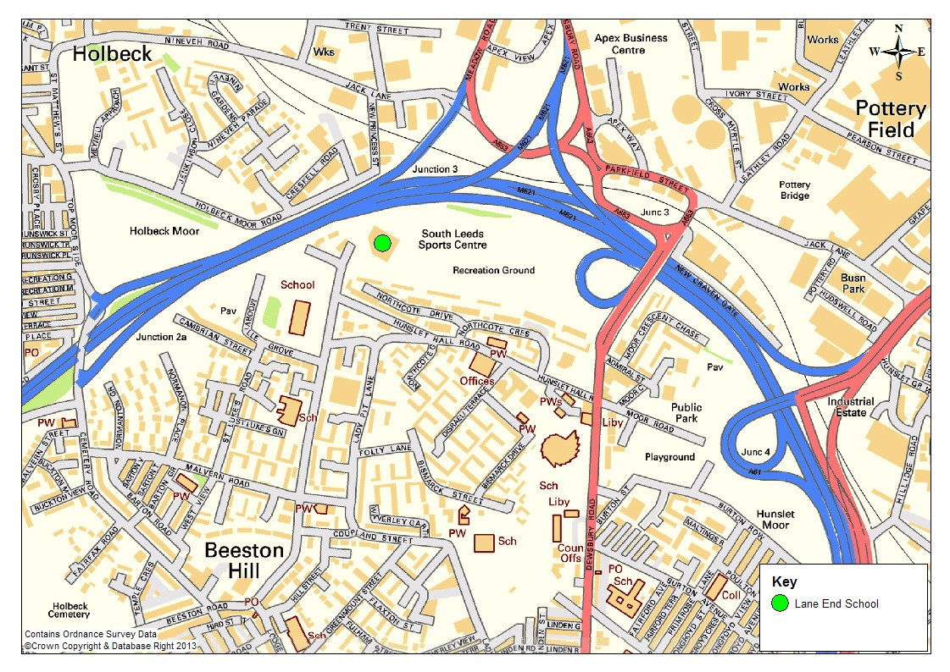

A site audit was undertaken on the 13th August 2012 to identify any potential barriers or opportunities for sustainable travel choices. There are a number of car free routes that would make walking to the site attractive. These include the route from the west through Holbeck Moor Road and onto Lane End Place and the route from the east, from Dewsbury Road, that runs parallel to the site and Northcote Drive.

The pedestrian path and cycle path on Lane End leading to Holbeck Moor Road is, however, worn, overgrown and in its current state provides safety concerns particularly at night. Additionally, there is a wide path on Holbeck Moor Road and a walking route through the park.

    - Local Bus Network
There are two bus stops located on either side of Hunslet Hall Road located approximately 150 metres south east of the site. There are numerous services which operate from these locations, providing access to the city centre and beyond, and throughout South Leeds. Figure 4-4 illustrates the location of the bus stops in relation to the proposed development and Table 4-3 details the bus services and frequencies.

Figure 4-4 - Local Bus Network Stops
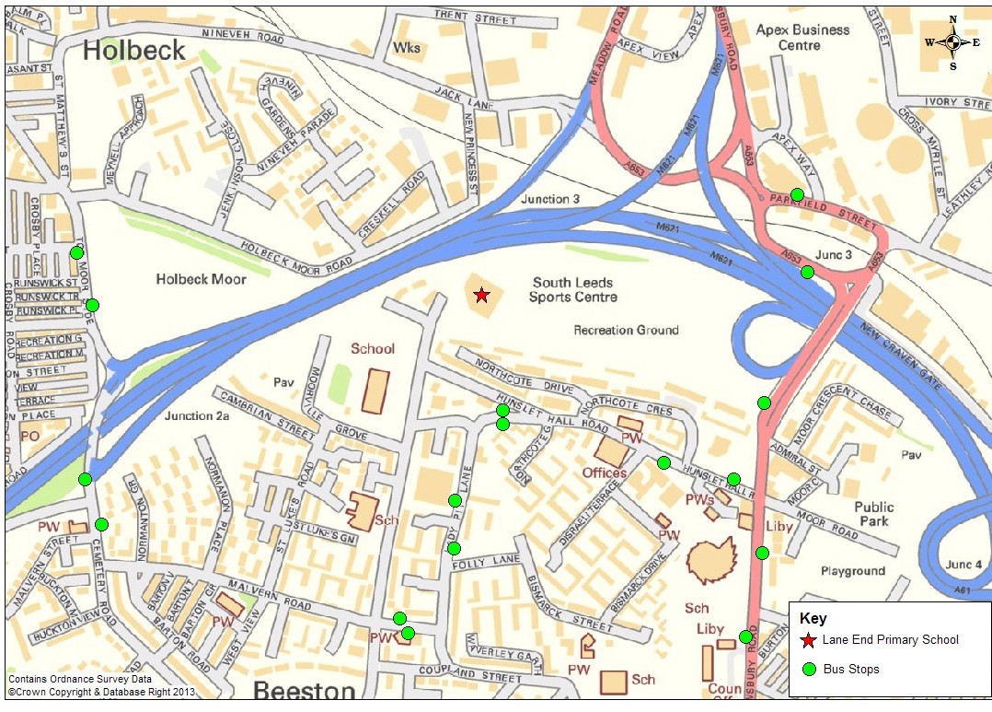

There are several existing bus stops within easy walking distance of the site access, providing access to frequent bus services to Beeston and wider area. The closest bus stop to the site, on Lady Pit Lane, is served by bus numbers 1 and 86 which, on average, sees eight buses per hour in each direction during the week.

Table 4-3 – Local Bus Services



Operator | Service Number | Route | Frequency (Mon-Fri) – each direction
First | 1 | Beeston-Leeds- Holt Park | 6 per hour
First | 2 | Middleton – Roundhay Park | 6 per hour
First | 3/3A | White Rose Centre – Brackenwood | 6 per hour
First | 86 | Pudsey-Bramley- Middleton | 2 per hour
First | 51/52 | Moor Allerton – Morley | 8 per hour
First | 55 | Moor Allerton- Leeds-Morley | 2 per hour
First | 64 | Gildersome – Aberford | 2 per hour
First | 74 | Middleton – Belle Isle Sharp House | 2 per hour
Arriva | 117 | Wakefield- Ossett-Leeds | 1 per hour

Operator | Service Number | Route | Frequency (Mon-Fri) – each direction
Arriva | 202/203 | Leeds-Dewsbury- Huddersfield | 4 per hour
Arriva | 220/221 | Mirfield-Leeds | 4 per hour
Arriva | 481 | Leeds-Middleton- Wakefield | 1 per hour

Table 4-3 above demonstrates there are bus services to/from the stops near to proposed development serving an extensive area with good links to the city centre and beyond, and throughout South Leeds.

    - Cycle Network
Figure 4-5 below illustrates the development site location in proximity to the local cycle network. It can be seen that cycling could offer part of a linked trip for some staff at the school with linkages to traffic free cycle paths and national cycle routes.

Lane End Primary School,
Travel Plan

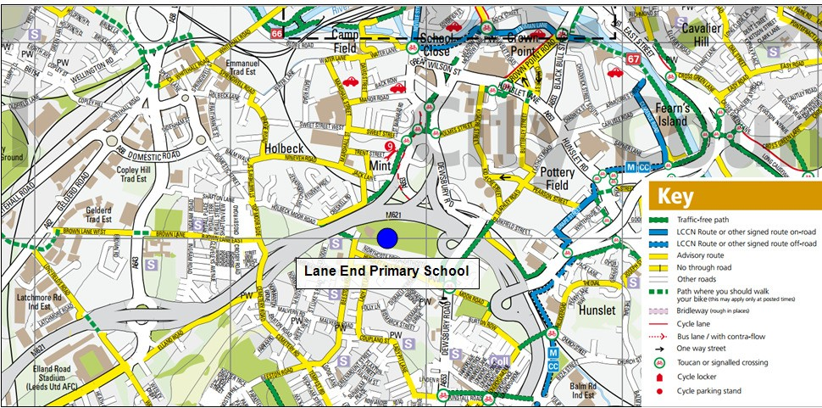
Figure 4-5 – Local Cycle Network
Map extract taken from http://www.leeds.gov.uk/docs/Leeds%20Cycling%20Map%20-%20South.pdf

14
© Mouchel 2013

It was noted within the site audit that as with pedestrians, cyclists would be able to take advantage of the car free routes through Holbeck Moor Road, Lane End Place and with use of the path that connects the site with Dewsbury Road.

    - Rail Network
Lane End Primary School is located approximately two miles from the City Centre and as such linked trips with Leeds Station may be suitable for some members of staff at the School. Bike and rail or PlusBus ticketing provides opportunities for sustainable travel choices. Figure 4-6 shows the Lane End site in relation to Leeds Station.

Figure 4-6 – Local Rail Network
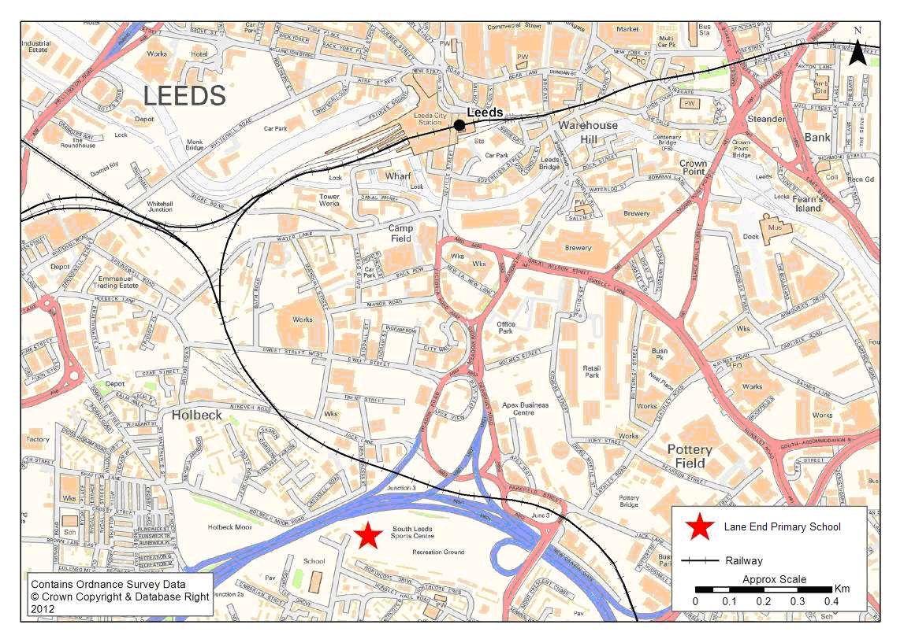

Details of the Proposed Development
The proposed opening year of the school pupils is 2014, however; the school will not take on board any pupils on the site until 2015. The 2014 pupil intake will be accommodated temporarily at Cockburn High School. For the 2015 academic year, these pupils will transfer to the Lane End School site in addition to the new reception intake. The Lane End Primary School site is not proposed to be fully occupied until 2020.

The Transport Assessment accompanying this submission assesses the impact of the development on the local highway network. The Transport Assessment provides details of highways and public rights of way measures to enhance the safety and attractiveness of the journey to school by sustainable means.

Lane End Primary School Site Summary

Table 4-4 – Lane End Primary School Summary

Head teacher | Asa Britton
Address | Beeston Road, Leeds LS11 6AA
Telephone number | 0113 3857910
Number of students on roll | 38 (June 2015) 120 estimated (Sept 2015)
Number of staff (including non teaching) | 20
School type | Foundation Primary
DFE School Reference Number | 383 /2000
Description of school catchment | Inner South
Cycle parking facilities (location/number of spaces/restrictions/permits/charges) | 28 places
Car parking provision (location/number of spaces/restrictions/permits/ charges) | TBC
The outline of any other use made of the school premises such as after school club | TBC

Travel Behaviour – Local Schools

Introduction
Leeds City Council holds PLASC (Pupil Level Annual School Census) data for all schools within the district which is collected and recorded on an annual basis. Data for the last academic year (2011/2012) has been obtained for Primary schools within a 0.75 mile radius of the proposed Lane End Primary School. The Primary schools are as follows:

    - Beeston Hill St Luke’s Church of England Primary School
    - Greenmount Primary School
    - Hunslet Moor Primary School
    - New Bewerley Community School
    - St Francis of Assisi Catholic Primary School
    - Ingram Road Primary School

It is felt that these schools reflect ‘typical’ travel behaviour reflective of the district and their proximity to the Lane End site demonstrates similar travel conditions and opportunities.

Pupil Travel Survey – Local Schools - 2011/2012 Academic Year
The modal split data for pupil travel over the 2011/2012 academic year for each of the schools above has been used to produce an average across all six schools; this can be seen in the table below.
Table 5-1 – 2011/2012 Travel Mode Survey Results

Modes of travel | %
Walk | 81%
Car/Van | 14%
Public Bus Service | 3%
Car Share | 1%
Bus | 0%
Taxi | 1%
Cycle | 0%
Other | 0%
Total | 100%

Staff Travel Survey
Staff travel by mode has been taken from Travel Plans of the same schools where feasible*. Table 5-2 sets out the average staff modal split data.

Table 5-2 – Average Staff Travel Mode Survey Results

Average Neighbouring School Data | Walk | Cycle | Bus | Train | Car | Car Share | Taxi | Total
 | 25% | 1% | 6% | 0% | 65% | 3% | 0% | 100%
*Beeston St Luke’s Travel Plan contained no staff modal split or targets; Hunslet Moor’s ‘No Response’ rate was 77%. Ingram Road Travel Plan modal split was incomplete. These schools were therefore not included in the above calculations.

It is shown that single occupancy car use, on average, accounts for two thirds of staff

Objectives

Introduction
Travel Plans offer a package of measures to encourage users to travel more sustainably, and as highlighted, they can deliver real benefits and align with a range of national and local policy objectives. This section sets out the high-level objectives and travel planning vision of Lane End Primary School.

Lane End School Travel Plan Vision & Objectives
As part of the implementation of the Travel Plan it is important to outline the overriding vision and objectives that will govern what the Travel Plan does and intends to achieve. This provides the framework from which all sustainable transport initiatives and mode shift targets are developed and will ensure that there is a clear overall goal. It will also be important to implement a series of objectives from which specific targets can be developed, as well as a basis for how Lane End Primary tackles its specific transport challenges.

    - Lane End School Travel Plan Vision
The following vision will be adopted for the site:

‘To improve the health and safety of its pupils, staff and local community by encouraging cycling and walking to school, and reducing car use, traffic speed and congestion around the school in order to create a healthier and safer environment for the whole school community.’

    - Lane End School Travel Plan Objectives
The high level aims outlined below have been informed and developed through a review of the existing national and local policy. The following Travel Plan objectives will be adopted for Lane End Primary School:

Objective 1 (O1) – Increase levels of walking; Objective 2 (O2) – Increase levels of cycling; Objective 3 (O3) – Increase levels of bus use;
Objective 4 (O4) – Encourage staff to travel sustainably;

Objective 5 (O5) – Reduce congestion and improve road safety around the school site.

    - Travel Plan Timeframe
In line with the development proposals, the Travel Plan will cover the period up until 2020 to provide a sustainable travel framework from which to mitigate against the impact of the increase in pupil and staff numbers. It will also be important for the plan

to continue to be an active document once the school has reached full capacity, in order to consolidate the measures in place, and the achievements up to that point.

The Travel Plan will be in place to cover the school development period up until 2020 and then the steady state phase once the school site is at full 2FE capacity. This will ensure that the school develops within a sustainable travel framework, minimising the impact of the increase in people travelling to the site on the surrounding area.

Travel Plan Targets

Introduction
To ensure that the objectives identified within Section 6 are achieved, and to form part of the ongoing monitoring, a set of ambitious yet realistic targets are essential. The existing modal split of other neighbouring schools has been presented in Section 5.2.

Table 7-1 includes a baseline modal split, which is based on the average modal split data for neighbouring schools. This has been used to generate provisional modal split targets to 2020.

Following the school opening (at the Lane End Primary School site) in 2015, a pupil ‘hands up’ survey will be undertaken within the first 3 months of occupation (see Action Plan in Appendix A for full details). Based on this survey, an actual baseline modal split can be established in terms of number of pupils and overall percentage. This data will replace the provisional baseline data included within Table 7-1. This information will be shared with the Leeds TravelWise team who, in partnership with the school head teacher and Travel Plan Coordinator, will review and revise the provisional targets for the subsequent years up to 2020.
Table 7-1 – Pupil Mode Split Targets

Pupil Targets | 2014* |  | 2015** (baseline) |  | 2016*** |  | 2017*** |  | 2018*** |  | 2019*** |  | 2020***
Mode | No. | % | No. | % | No. | % | No. | % | No. | % | No. | % | No. | %
Walk |  | - |  | 81% |  | 82% |  | 83% |  | 84% |  | 85% |  | 86%
Car/Van |  | - |  | 14% |  | 13% |  | 12% |  | 11% |  | 10% |  | 9%
Public Bus Service |  | - |  | 3% |  | 1% |  | 1% |  | 1% |  | 1% |  | 1%
Car Share |  | - |  | 1% |  | 1% |  | 1% |  | 1% |  | 1% |  | 1%
School Bus |  | - |  | 0% |  | - |  | - |  | - |  | - |  | -
Taxi |  | - |  | 1% |  | - |  | - |  | - |  | - |  | -
Cycle |  | - |  | 0% |  | 1% |  | 1% |  | 2% |  | 3% |  | 3%
*Data n/a due to pupils travelling to a different school site.
**Local average survey data has been used as an initial baseline. This will be amended based on the results of the initial pupil survey following occupation.
***Subsequent targets to be reviewed following the initial baseline survey.

The provisional targets included above are designed to seek an annual reduction in single occupancy car use whilst encouraging the use of more sustainable modes of travel.

As with the pupil targets, the staff targets should seek to achieve an increase in the use of more sustainable modes over time, and a reduction in single occupancy car use. Once the Lane End School site is open and operational, a baseline travel survey will be undertaken within the first 3 months (see Section 12) to establish the actual modal split. Table 7-2 below includes provisional targets based on the modal split for teachers at neighbouring schools. Once an actual baseline has been established, the survey data will replace the provisional baseline modal split and the subsequent targets will be reviewed.

Table 7-2 – Staff Mode Split Targets

Pupil Targets | 2014* |  | 2015** (baseline) |  | 2016*** |  | 2017*** |  | 2018*** |  | 2019*** |  | 2020***
Mode | No. | % | No. | % | No. | % | No. | % | No. | % | No. | % | No. | %
Walk |  | - |  | 24% |  | 26% |  | 27% |  | 28% |  | 29% |  | 30%
Car/Van |  | - |  | 65% |  | 62% |  | 62% |  | 59% |  | 57% |  | 55%
Bus |  | - |  | 6% |  | 6% |  | 6% |  | 6% |  | 6% |  | 6%
Car Share |  | - |  | 4% |  | 4% |  | 4% |  | 4% |  | 4% |  | 4%
Train |  | - |  | 0% |  | - |  | - |  | - |  | - |  | -
Taxi |  | - |  | 0% |  | - |  | - |  | - |  | - |  | -
Cycle |  | - |  | 1% |  | 2% |  | 2% |  | 3% |  | 4% |  | 5%
*Data N/A due to staff travelling to a different school site.
**Local average survey data has been used as an initial baseline. This will be amended based on the results of the initial staff survey following occupation.
***Subsequent targets to be reviewed following the initial baseline survey.

It is recommended that the school shares the staff survey data with the Leeds TravelWise team who will advise when the provisional targets are reviewed over the period up to 2020. Overall, the targets are designed to seek an annual reduction in single occupancy car use whilst encouraging the use of more sustainable modes.

Travel Plan Measures

Travel Plan Measures
There are a range of sustainable transport solutions that can help achieve the objectives and targets set out within this document and to help deliver a holistic approach to sustainable travel to the school.

It is important that the correct measures for our school are implemented based on the anticipated and possible future transport challenges experienced by the school. Each measure will be reviewed regularly to ensure that they remain relevant as well as to ensure that that the targets remain realistic.

Ongoing Initiatives
The school will undertake ongoing initiatives through the lifetime of the Travel Plan. These are summarised in the subsections below:

    - Staff and Pupil Travel Survey
The staff and student travel surveys will nprovide the basis from which all smarter travel measures are developed. In addition to the annual pupil survey, all school staff (full time employees and part time employees) will complete a home to school travel survey. The school must complete the travel to school question in the school census annually.

The views and opinions of parents/guardians relating to travelling to the school site will also be sought and collated on an annual basis. This will help to provide further insight into the main travel and transport problems and issues including safety.

    - School Website
The Lane End Primary School Website will be a key tool in promoting and advertising all travel planning measures and travel information. The website provides a focal point from which parents, staff and visitors can access information as and when required, and is an effective way of communicating to the key groups. As such, the School Travel Plan will be available electronically via the website.

Measures for Pupils
    - Walking Initiatives
The school will undertake at least one walking initiative per academic year. This could be any initiative from a wide range of initiatives which are promoted by Leeds City Council’s TravelWise team. The following bullet points provide examples of such initiatives.

      - WalkingBuses;

      - WalkonWednesday;

      - Walkshare;

      - Walk to School week.

    - Cycling Initiatives
The school will undertake at least one cycling initiative per academic year, when it age appropriate to do so. The following bullet points examples of such initiatives.

      - Cycle buddy scheme;

      - Bike week;

      - Cycle training (Bikability).

    - Cycle Parking
Cycling can offer significant potential in reducing car use amongst pupils. As part of the development there will be cycle storage facilities to accommodate 28 bicycles. These facilities will be situated in a prominent location, at the school entrance but away from the road to avoid theft.

    - Providing equipment
The Travel Plan working group will look at the potential to provide pupils with safety equipment, such as bike helmets or high-visibility vests.

    - Promoting Public Transport
The school will promote the use of public transport for families and pupils wherever possible, through incorporating buses into road safety training, and also, where feasible, providing leaflets and maps within the school.

Measures for Staff
    - Car Share Scheme
The Travel Plan Coordinator will investigate the feasibility of implementing a staff car-share system. As new staff join the school they will be informed of the scheme
and invited to become part of it. All staff that car-share or who are willing to car-share will be advertised via staff newsletters and staff notice boards.

    - West Yorkshire Travel Plan Network
The Travel Plan Coordinator will sign the Lane End Primary School up to the West Yorkshire Travel Plan Network.

    - Public Transport Ticketing
Staff will be made aware of various ticketing offers including discounted metro card and cycle to work scheme. Maps and leaflets displaying bus stops, routes and timetables will also be provided in staff areas.

    - Car Park Management Plan
In order to effectively manage the car parking arrangements the school will implement an operational parking plan. The plan should provide the following:

      - A set time for Staff to access the School Car Park. Staff will be encouraged to arrive by a set time prior to pupils arriving at the school.

      - Delivery and logistics vehicles will be encouraged to arrive after the peak period and/or at defined times.

      - Priority parking for those with heavy or bulky equipment to spaces closest to the school building entrance.

      - Investigate the feasibility of encouraging staff to look at using Parkatmyhouse.com. The website is free to sign up to and provide details of cost effective parking within a given area that is provided by local people.

The Travel Plan Coordinator will design and implement an operational car parking plan within 6 months of the school opening.

Travel Plan Management

Managing Smarter Travel
    - Travel Plan Coordinator
The Travel Plan Coordinator will manage the Travel Plan process at the Lane End Primary School, and will be responsible for implementing the agreed measures, promoting the benefits of the Travel Plan and acting as the point of contact for all travel and Travel Plan matters. The Travel Plan Coordinator will also organise the Travel Plan Forum as necessary and be the main point of contact with LCC School Travel Plan Coordinator.

    - Working Group
A Travel Plan working group will be established. This group (including staff, pupils and parents) will help to steer and promote the Travel Plan when it comes into effect in 2015.

    - Travel Plan Commitment
As part of the management process, the key School stakeholders will sign a Travel Plan Commitment Charter, outlining the Lane End Primary School’s commitment to the Travel Plan over the specified period (see Appendix B).

    - Travel Plan Delivery Team
Against each measure within the Action Plan there will be assigned leads and timescales to ensure that the Travel Plan is delivered.

Marketing & Promotion

Promotion & Marketing
To ensure the measures and interventions taken forward as part of the Travel Plan are capitalised upon, to help improve safety, reduce car use and encourage sustainable travel, a series of promotional and marketing activities will be essential.

The Co-ordinator will be responsible for the Travel Plan promotion by:

- Publishing the Travel Plan and making it available through the School Website;
- Promoting initiatives, when applicable, through the school newsletter and information leaflets;
- Including the Travel Plan in the school development / improvement plan;
- Indicating commitment to related initiatives, such as healthy schools, eco schools and sustainable schools, road safety (when it is age appropriate to do so); and
- Introducing annual activities and events such as walk to school week.

This will involve building relationships with the local press and media. The pupils will be encouraged to take part in promotion and marketing, where appropriate, as part of the curriculum through art and design orientated studies.

Delivery mechanism
The Travel Plan Coordinator will be responsible for delivering the Travel Plan. The Coordinator will be responsible for promotion, managing targets and measures, liaising with interested groups, providing reports, and coordinating other activities related to the Travel Plan implementation.

Monitoring & Review

Monitoring
Constant monitoring and continual data collection will be in place and as such will provide a solid foundation from which to develop new strategies in line with the school’s continued growth.
The Travel Plan will be monitored annually, through the School Improvement Plan. This will involve analysing the survey data and undertaking specific questionnaires to help capture quantitative and qualitative data, and help the school to take ownership of the Travel Plan. The School will annually review all its initiatives to ensure the Travel Plan is being effective at promoting and facilitating sustainable travel to and from school.
The monitoring of travel planning activity and travel patterns should be a consistent and standardised process; therefore Lane End Primary School will adhere to the monitoring timetable outlined below.

Table 11-1 School Travel Plan - Monitoring Plan

Year | Action
2014 – Opening Year* | Travel Plan Coordinator Named Working group formed.  Prepare full action plan with specified dates as well identifying persons responsible  TPC to update LCC
2015** | Adoption of Lane End School Travel Plan  Baseline Pupil and Staff Survey Undertaken
2016 | Full Annual Travel Plan Survey, Health Check
2016 | Travel Plan discussed at School Governor’s AGM
2017 | Full Annual Travel Plan Survey and Health Check
2017 | Travel Plan discussed at School Governor’s AGM
2018 | Full Annual Travel Plan Survey and Health Check
2018 | Travel Plan discussed at School Governor’s AGM
2019 | Full Annual Travel Plan Survey and Health Check
2019 | Travel Plan discussed at School Governor’s AGM
2020 | Full Travel Plan Review
*Initial reception intake will be temporarily based at Cockburn High School, not Lane End Primary School.
**First year on the site of Lane End Primary School. Pupils temporarily based at Cockburn High School will transfer over to Lane End, plus the reception intake for the year.

A summary of the annual review will be reported to the pupils, parents and LCC to help further promote sustainable travel and to ensure that the Travel Plan continually evolves.

Review & Evaluation
A summary of the yearly review will be reported to the pupils, parents and LCC to help further promote sustainable travel.

Future Travel Plan Development
The Travel Plan and all measures will be reviewed on an annual basis up until 2020. The Travel Plan will effectively be a live document and be updated on an annual basis as required. The Travel Plan Forum will also ensure that the document remains current and that all initiatives and measures remain relevant to the School.

Action Plan

A Travel Plan is an evolving document that adapts to provide realistic travel choices to those at which it is aimed. The Action Plan, (see Appendix A), provides the basis for delivering the Travel Plan but will remain a ‘live’ document.

Appendix A

Table A - 1 – Lane End Primary School General Action Plan
General Action Plan
Action | Date | Individual/s Responsible | Objective | Outcome | Measurement
Appointment of Travel Plan Coordinator | Within 3 months of the school opening at the Lane End Site (Luke Tabiner) | A.Britton | All Objectives:  O1 (Increase levels of walking) O2 (Increase levels of cycling), O3 (Increase levels of bus use),  O4 (Encourage staff to travel sustainably) O5 (Reduce congestion and improve road safety around school site) | Travel Plan Coordinator appointed and details published and provided to LCC | Governing Body
Travel Plan Working Group | Within 6 months of the school opening at the Lane End Site | A.Britton/L.Tabiner | All objectives (O1, O2, O3, O4, O5) | Working group members nominated and details circulated to all staff, LCC and parents and guardians. | Governing Body / Luke Tabiner
Circulate a Letter of Commitment | Within 3 months of the school opening at the Lane End Site site (2014) | A.Britton/L.Tabiner | All objectives (O1, O2, O3, O4, O5) | Letter circulated to all staff, pupils, parents and guardians | Luke Tabiner
Lane End Primary School Smarter Travel Guide | Within 6 months of the school opening | A.Britton/L.Tabiner | All objectives (O1, O2, O3, O4, O5) | Lane End Primary School Smarter Travel Guide created. | Luke Tabiner / Travel Plan Working Group
Lane End Primary School Smarter Travel Web information | Within 9 months of school opening | A.Britton/L.Tabiner | All Objectives (O1, O2, O3, O4, O5) | Lane End Primary School Smarter Travel Webpage link/info created and added to the School website. | Luke Tabiner / Travel Plan Working Group

General Action Plan
Action | Date | Individual/s Responsible | Objective | Outcome | Measurement
School to sign up to the West | Within 6 months of school | A.Britton/L.Tabiner | All objectives (O1, O2, O3, O4, O5) | School signed up to | Luke Tabiner
Yorkshire Travel Plan | opening | A.Britton/L.Tabiner | All objectives (O1, O2, O3, O4, O5) | the West Yorkshire | Coordinator/
Network and GenerationM, |  | A.Britton/L.Tabiner | All objectives (O1, O2, O3, O4, O5) | Travel Plan Network | Travel Plan
the pupil and teacher travel |  | A.Britton/L.Tabiner | All objectives (O1, O2, O3, O4, O5) | and GenerationM. | Working
planning resource centre |  |  |  |  | Group
(www.generationm.co.uk)

Table A - 2 – Lane End Primary School Pupil Action Plan

Pupil Action Plan
Action | Date | Individual/s Responsible | Objective | Outcome | Measurement
Pupils to take part in at least one walking initiative | Within the first academic year of the Lane End Primary School site opening (2015) | A.Britton/L.Tabiner | O1, O5 | Working group agree on the most appropriate walking initiative and implement. | L.Tabiner
Use Walkit.com | Within 6 months of the first academic year on the site of Lane End Primary School. | A.Britton/L.Tabiner | O1, O5 | Investigate the feasibility of creating pupil specific walk to school maps. | L.Tabiner
Pupils to take part in at least one cycling initiative | When the children enter Key Stage 2 (2017-) | A.Britton/L.Tabiner | O2, O5 | Working group agree on the most appropriate walking initiative and implement. | L.Tabiner
Providing Cycle Equipment | When the children enter Key Stage 2 (2017-) | A.Britton/L.Tabiner | O2, O4 | The feasibility of providing cycle safety information investigated and details provided to the TP Working Group | L.Tabiner/ Travel Plan Working Group

Pupil Action Plan
Action | Date | Individual/s Responsible | Objective | Outcome | Measurement
Market the Mybus Service through the school news letter | Within 6 months of the Lane End Primary School site opening. | A.Britton/L.Tabiner | O3, O5 | Increase Mybus use | L. Tabiner via PLASC/Metro Mybus register
Display service bus timetables in school | Within 6 months of the Lane End Primary School site opening | A.Britton/L.Tabiner | O3, O5 | Increase bus use | L.Tabiner via PLASC
Pupil Travel Survey | Within 6 months of the Lane End Primary School site opening. | A.Britton/L.Tabiner | O1, O2, O3, O5 | Standard staff and pupil survey created and details circulated to all staff, LCC and parents and guardians. | L.Tabiner (Survey)
Parental Involvement | Within 6 months of the Lane End Primary School site opening. | A.Britton/L.Tabiner Working Group | O1, O2, O4, O5 | Parents actively encouraged to become involved within the travel planning process. | L.Tabiner/ Travel Plan Working Group

Table 13-1 – Lane End Primary School Staff Action Plan
Staff Action Plan
Action | Date | Individual/s Responsible | Objective | Outcome | Measurement
Staff Travel Survey | Within 3 months of the Lane End Primary School site opening. | A.Britton/L.Tabiner | O1, O2, O3, O4, O5 | Standard staff and pupil survey created and details circulated to all staff, LCC and parents and guardians. | L.Tabiner
Use Walkit.com | Within 6 months of the Lane End Primary School site opening. | A.Britton/L.Tabiner | O1, O4, O5 | Use walkit.com to generate staff specific walk to school route maps | L.Tabiner
Staff Cycle Buddy Scheme | Within 6 months of the Lane End Primary School site opening. | A.Britton/L.Tabiner | O2, O4, O5 | Feasibility/interest explored | L.Tabiner

Staff Action Plan
Action | Date | Individual/s Responsible | Objective | Outcome | Measurement
Staff should sign up to the car share website. | Within 6 months of the Lane End Primary School site opening. | A.Britton/L.Tabiner | O4, 05 | Staff Car Share scheme implemented | L.Tabiner/ Travel Plan Working Group
Car Park Management Plan | On the opening of the Lane End Primary School site. | A.Britton/L.Tabiner | O4, O5 | Car Park plan shared with staff and in operation. | L.Tabiner/ Travel Plan Working Group

- Appendix B

Commitment Charter
The School is committed to delivering and taking forward the measures identified within this Travel Plan.

Signed:

……………………………………………… Head Teacher,
……………………………………………… Travel Plan Co-ordinator

……………………………………………… Working Group Member
……………………………………………… Working Group Member

……………………………………………… Working Group Member
……………………………………………… Working Group Member

- Appendix C – Proposed Highway Improvements

(Separate attachment)

- Appendix D – Proposed Site Layout

(Separate attachment)

